**Homepage**

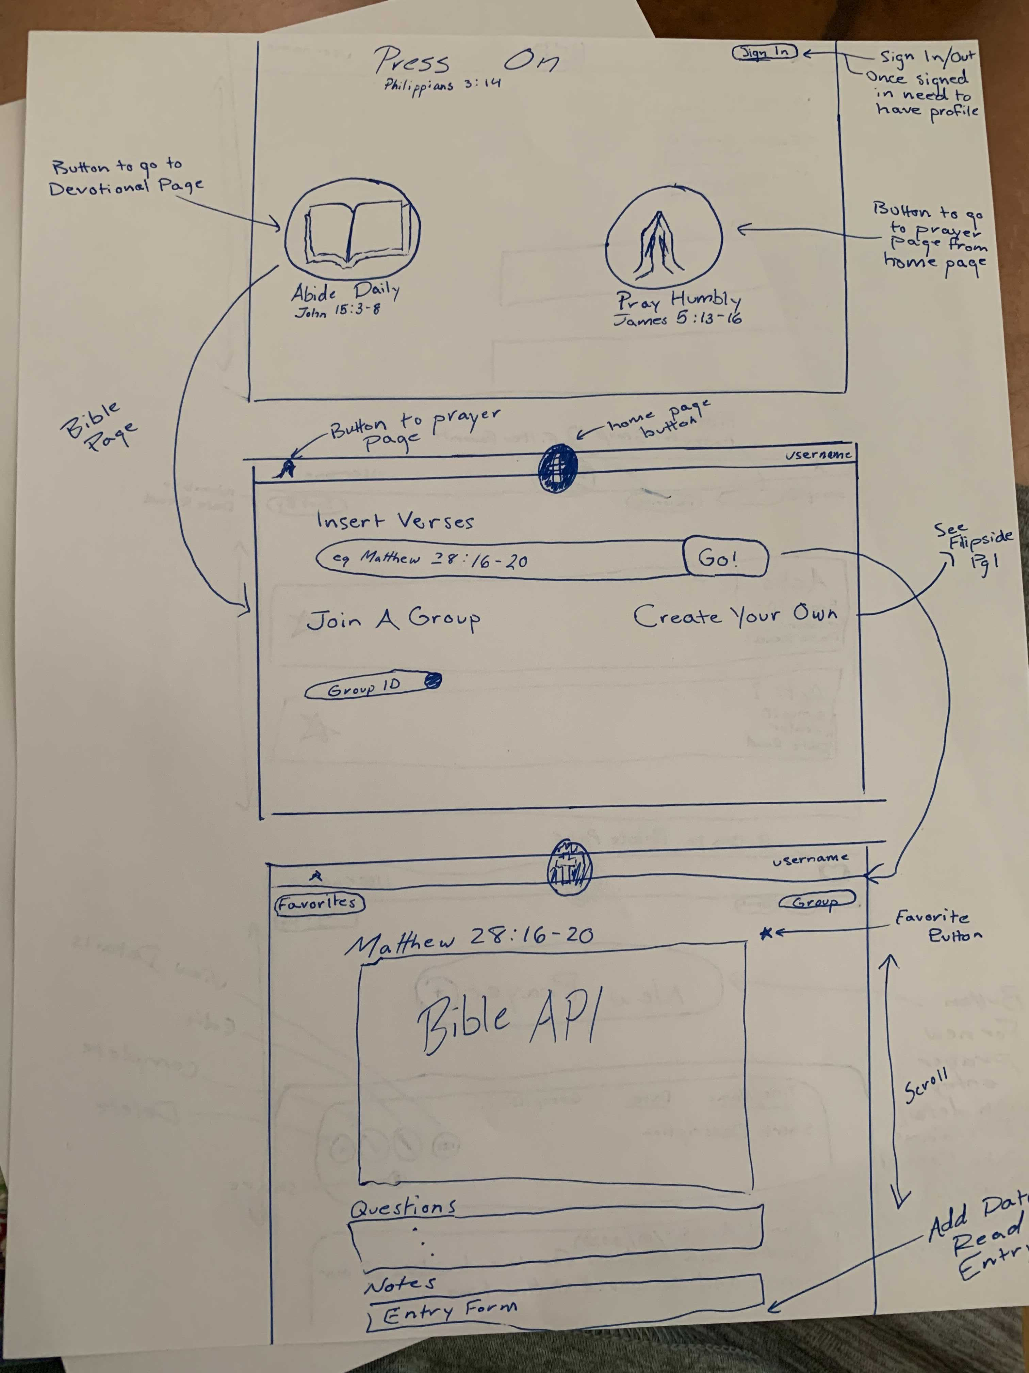

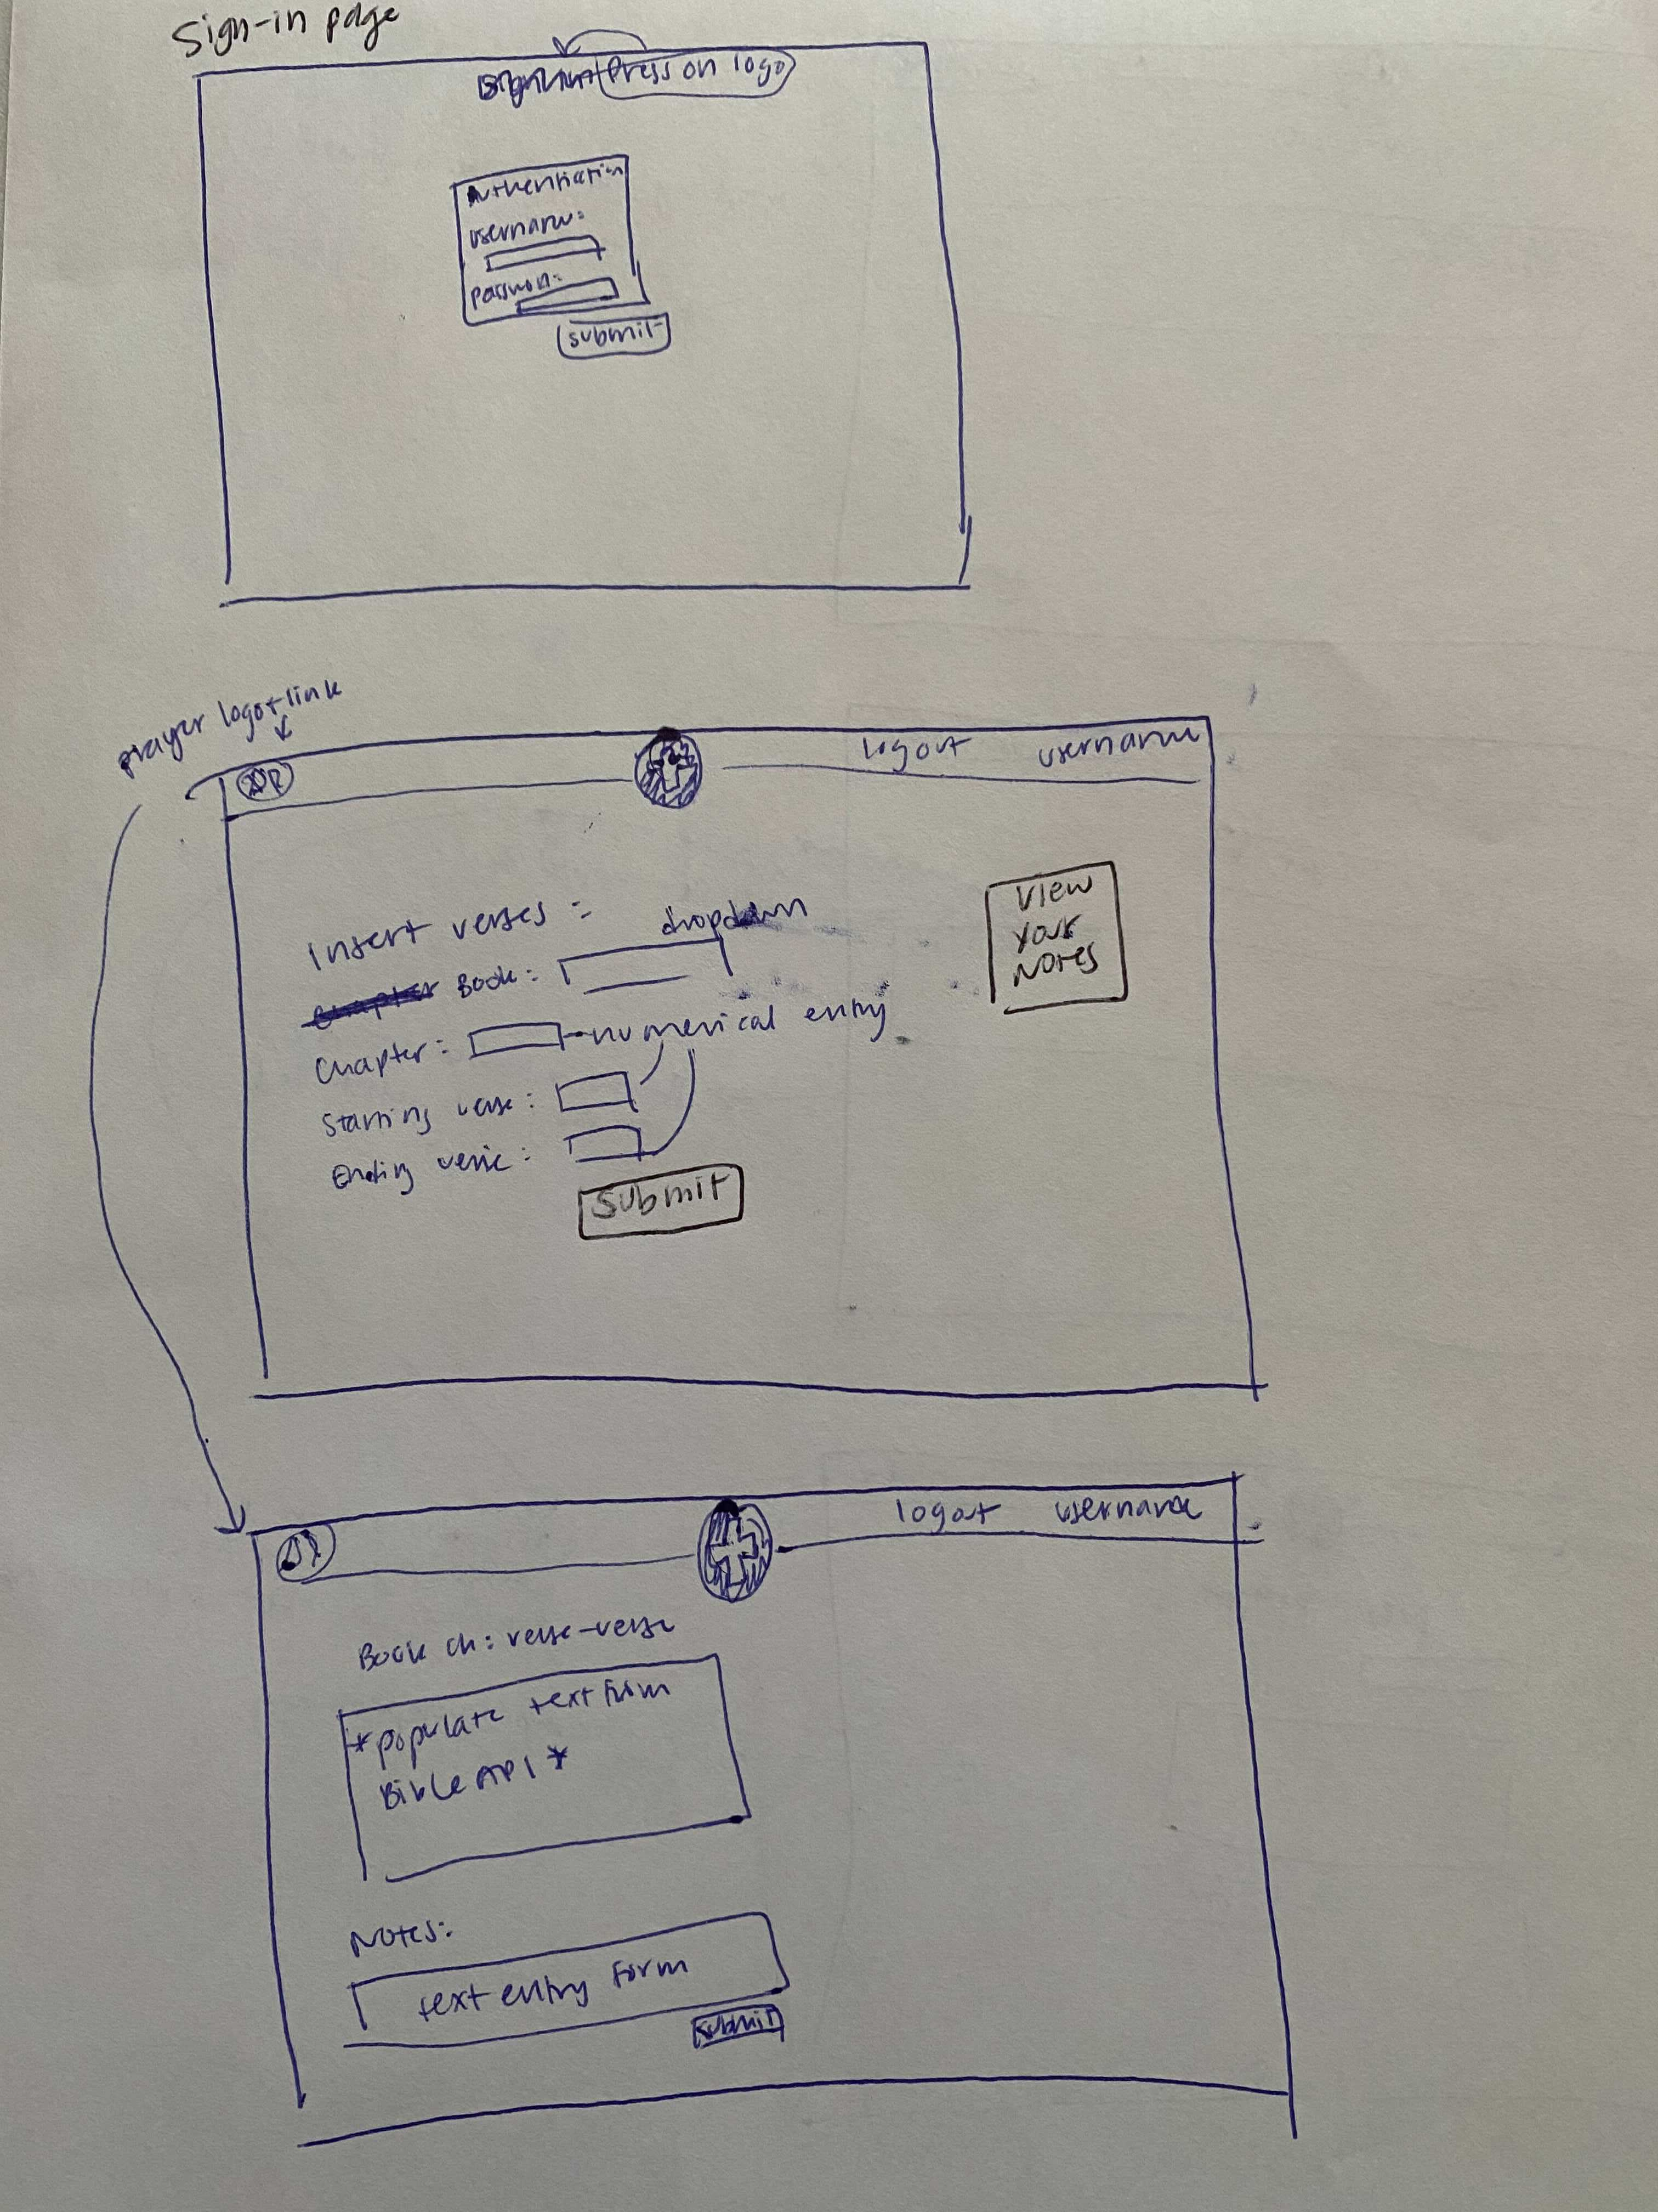

* “Abide Daily” and “Pray Humbly” buttons on first page direct to sign-in page when user is signed out
* On second page, once user has successfully logged in, goes to homepage, with “sign in” on top right replaced with username, and two links working

**Abide daily**



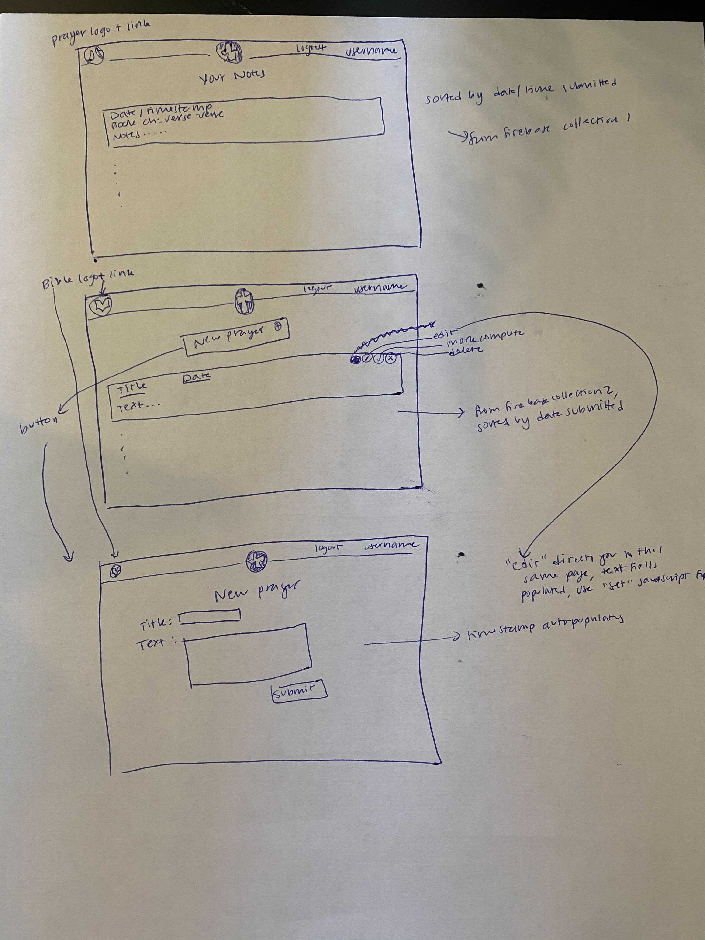

* Entry form on first page may look different depending on Bible API (could provide form that plugs in)
* “Submit” on first page takes user to second page
* “Submit” on second page adds notes content to Firebase collection of notes
* “View your notes” on first page takes you to third page; this is populated from Firebase collection of notes

**Pray humbly**



* Submit directs back to previous page, but with new prayer now in firebase + populating at top of prayer list